**TARGET STORE BUSINESS CASE STUDY USING SQL AND TABLEAU**

**Context:**

Target is a globally renowned brand and a prominent retailer in the United States. Target makes itself a preferred shopping destination by offering outstanding value, inspiration, innovation and an exceptional guest experience that no other retailer can deliver.

This particular business case focuses on the operations of Target in Brazil and provides insightful information about 100,000 orders placed between 2016 and 2018. The dataset offers a comprehensive view of various dimensions including the order status, price, payment and freight performance, customer location, product attributes, and customer reviews.

By analysing this extensive dataset, it becomes possible to gain valuable insights into Target's operations in Brazil. The information can shed light on various aspects of the business, such as order processing, pricing strategies, payment and shipping efficiency, customer demographics, product characteristics, and customer satisfaction levels.

**Dataset**: <https://drive.google.com/drive/folders/1TGEc66YKbD443nslRi1bWgVd238gJCnb>

The data is available in 8 csv files:

1. customers.csv
2. sellers.csv
3. order_items.csv
4. geolocation.csv
5. payments.csv
6. reviews.csv
7. orders.csv
8. products.csv

The column description for these csv files is given below.

The **customers.csv** contain following features:

|  |  |
| --- | --- |
| **Features** | **Description** |
| customer_id | ID of the consumer who made the purchase |
| customer_unique_id | Unique ID of the consumer |
| customer_zip_code_prefix | Zip Code of consumer’s location |
| customer_city | Name of the City from where order is made |
| customer_state | State Code from where order is made (Eg. são paulo - SP) |

The **sellers.csv** contains following features:

|  |  |
| --- | --- |
| **Features** | **Description** |
| seller_id | Unique ID of the seller registered |
| seller_zip_code_prefix | Zip Code of the seller’s location |
| seller_city | Name of the City of the seller |
| seller_state | State Code (Eg. são paulo - SP) |

The **order_items.csv** contain following features:

|  |  |
| --- | --- |
| **Features** | **Description** |
| order_id | A Unique ID of order made by the consumers |
| order_item_id | A Unique ID given to each item ordered in the order |
| product_id | A Unique ID given to each product available on the site |
| seller_id | Unique ID of the seller registered in Target |
| shipping_limit_date | The date before which the ordered product must be shipped |
| price | Actual price of the products ordered |
| freight_value | Price rate at which a product is delivered from one point to another |

The **geolocations.csv** contain following features:

|  |  |
| --- | --- |
| **Features** | **Description** |
| geolocation_zip_code_prefix | First 5 digits of Zip Code |
| geolocation_lat | Latitude |
| geolocation_lng | Longitude |
| geolocation_city | City |
| geolocation_state | State |

The **payments.csv** contain following features:

|  |  |
| --- | --- |
| **Features** | **Description** |
| order_id | A Unique ID of order made by the consumers |
| payment_sequential | Sequences of the payments made in case of EMI |
| payment_type | Mode of payment used (Eg. Credit Card) |
| payment_installments | Number of installments in case of EMI purchase |
| payment_value | Total amount paid for the purchase order |

The **orders.csv** contain following features:

|  |  |
| --- | --- |
| **Features** | **Description** |
| order_id | A Unique ID of order made by the consumers |
| customer_id | ID of the consumer who made the purchase |
| order_status | Status of the order made i.e. delivered, shipped, etc. |
| order_purchase_timestamp | Timestamp of the purchase |
| order_delivered_carrier_date | Delivery date at which carrier made the delivery |
| order_delivered_customer_date | Date at which customer got the product |
| order_estimated_delivery_date | Estimated delivery date of the products |

The **reviews.csv** contain following features:

|  |  |
| --- | --- |
| **Features** | **Description** |
| review_id | ID of the review given on the product ordered by the order id |
| order_id | A Unique ID of order made by the consumers |
| review_score | Review score given by the customer for each order on a scale of 1-5 |
| review_comment_title | Title of the review |
| review_comment_message | Review comments posted by the consumer for each order |
| review_creation_date | Timestamp of the review when it is created |
| review_answer_timestamp | Timestamp of the review answered |

The **products.csv** contain following features:

|  |  |
| --- | --- |
| **Features** | **Description** |
| product_id | A Unique identifier for the proposed project. |
| product_category_name | Name of the product category |
| product_name_lenght | Length of the string which specifies the name given to the products ordered |
| product_description_lenght | Length of the description written for each product ordered on the site |
| product_photos_qty | Number of photos of each product ordered available on the shopping portal |
| product_weight_g | Weight of the products ordered in grams |
| product_length_cm | Length of the products ordered in centimeters |
| product_height_cm | Height of the products ordered in centimeters |
| product_width_cm | Width of the product ordered in centimeters |

**What does 'good' look like?**

1. **Importing the dataset and performing usual exploratory analysis steps like checking the structure & characteristics of the dataset:**

Data type of all columns in the “customers” table

QUERY WRITTEN IN BIGQUERY



OUTPUT

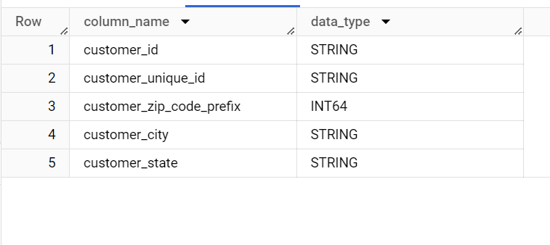

The customers table contain 5 columns namely customer_id with string datatype , customer_unique_id with string datatype , customer_zip_code_prefix with integer datatype , customer_city a nd customer_state with string datatype

1. Get the time range between which the orders were placed.

To get the date_range , we need the earliest order_purchased_date and latest one and finslly find the number of days between them.

QUERY

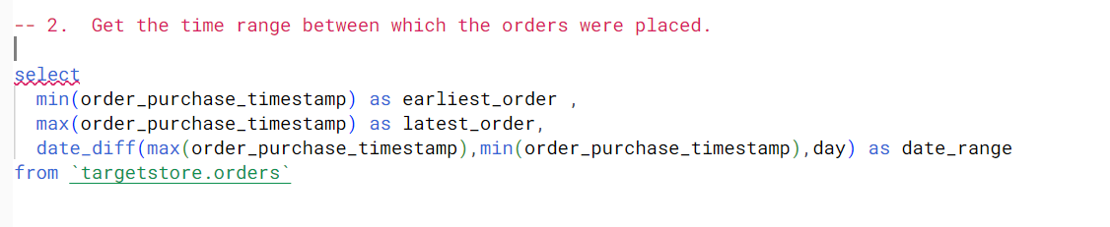

OUTPUT

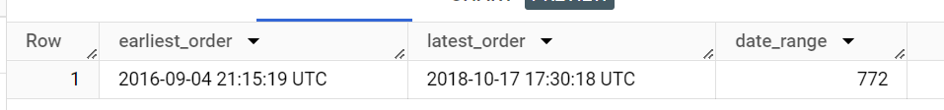

1. Count the Cities & States of customers who ordered during the given period.

QUERY

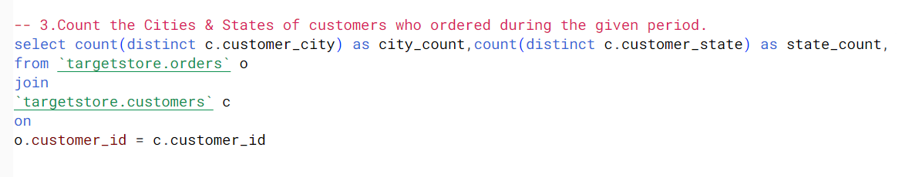

OUTPUT

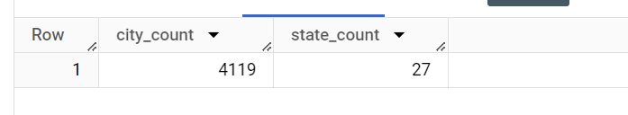

**Evolution of E-commerce orders in the Brazil region:**

1. Getting the month on month no. of orders placed in each state.

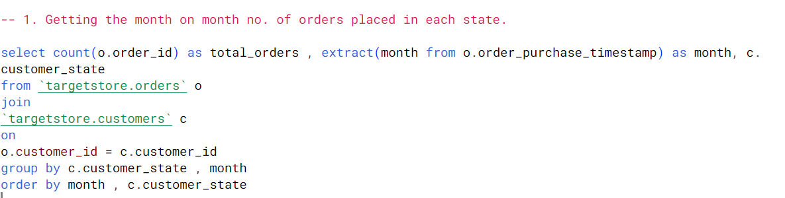

Output

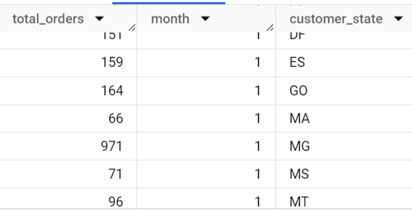

1. How are the customers distributed across all the states?

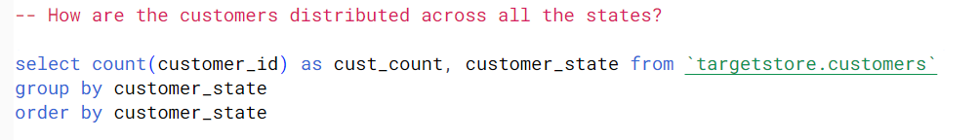

OUTPUT

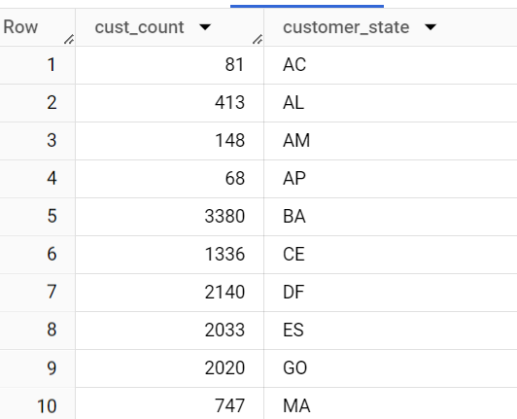

**Impact on Economy: Analyse the money movement by e-commerce by looking at order prices, freight and others.**

1. Get the % increase in the cost of orders from year 2017 to 2018 (include months between Jan to Aug only).

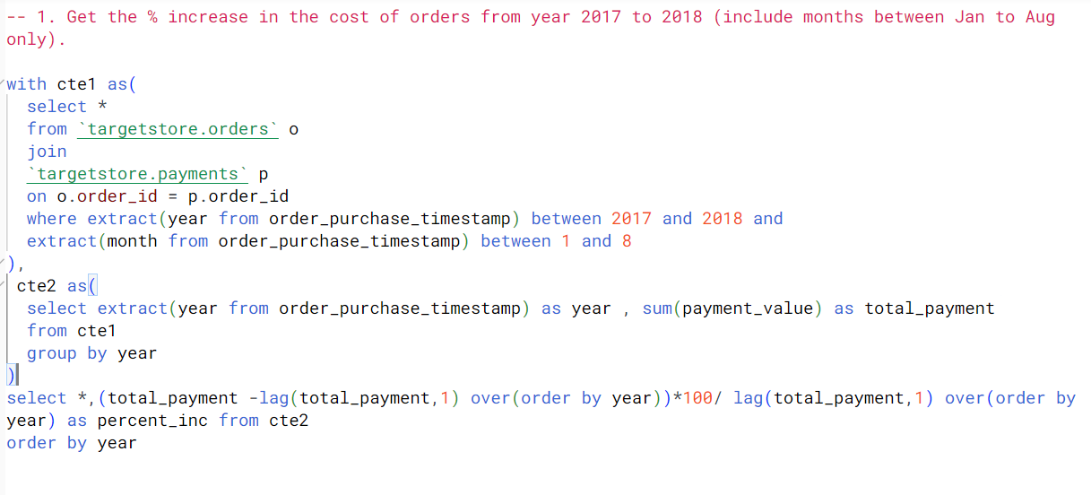

OUTPUT

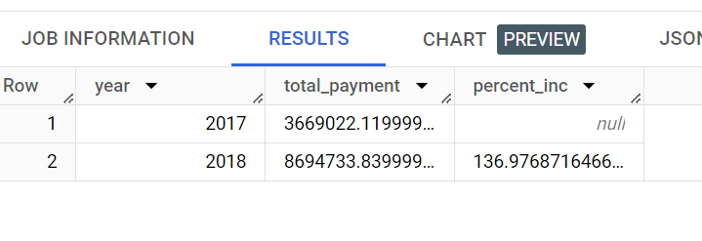

INFERENCE : Output shows that there was 137% increase in the cost of orders from year 2017 to 2018.

1. Calculate the Total & Average value of order price for each state.

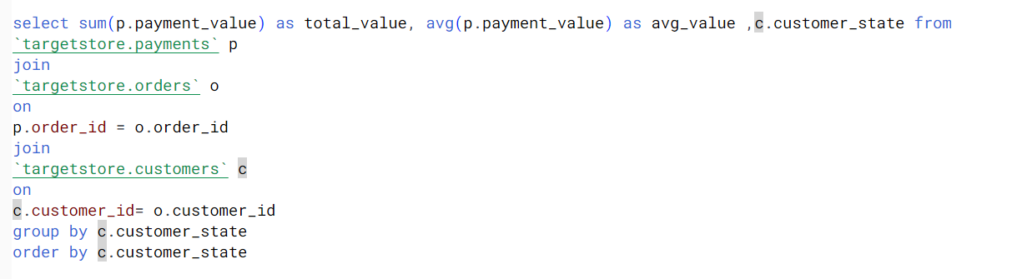

OUTPUT

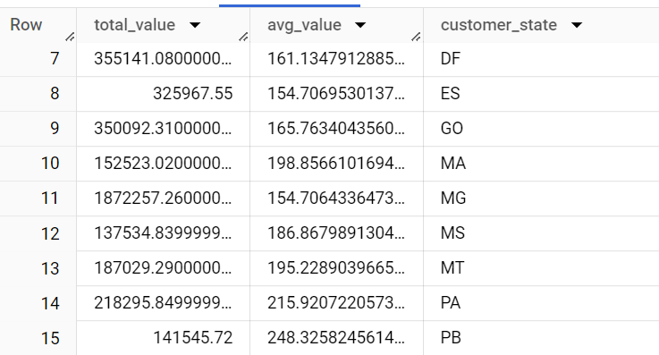

1. Calculate the Total & Average value of order freight for each state.

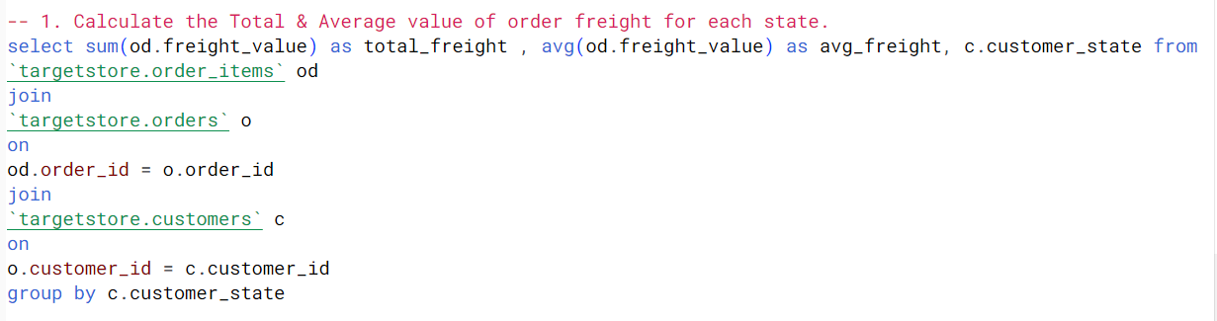

OUTPUT

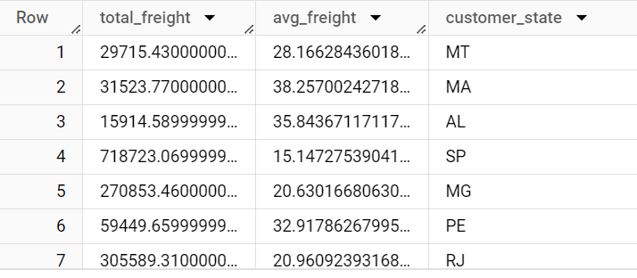

**Analysis based on sales, freight and delivery time.**

1. Find the no. of days taken to deliver each order from the order’s purchase date as delivery time.  
   Also, calculate the difference (in days) between the estimated & actual delivery date of an order.  
   Do this in a single query.

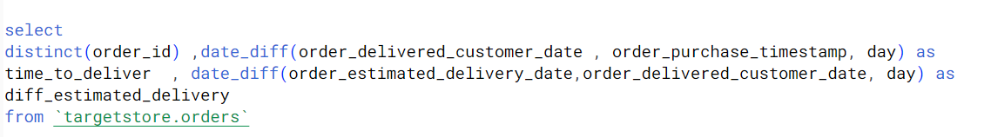

OUTPUT

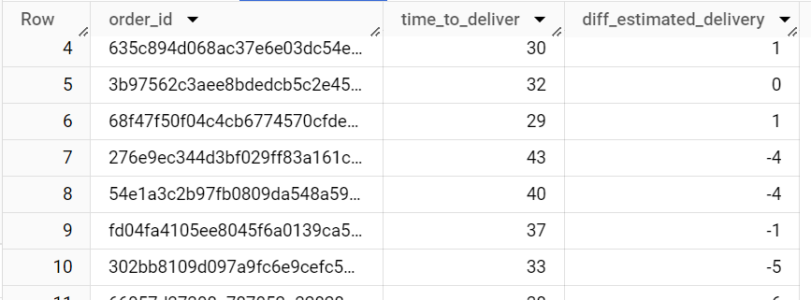

1. Find out the top 5 states with the highest & lowest average freight value.

For highest average freight value

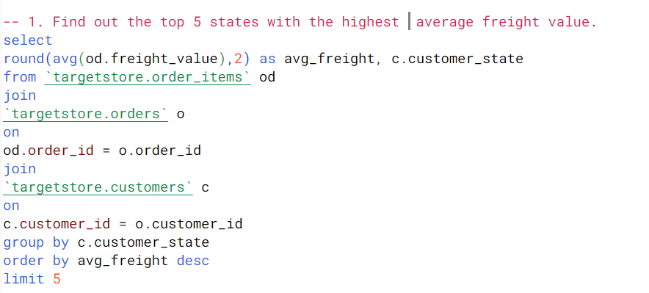

OUTPUT

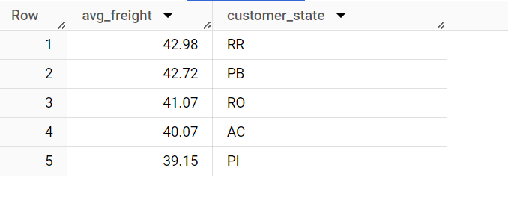

LOWEST AVERAGE FREIGHT VALUE

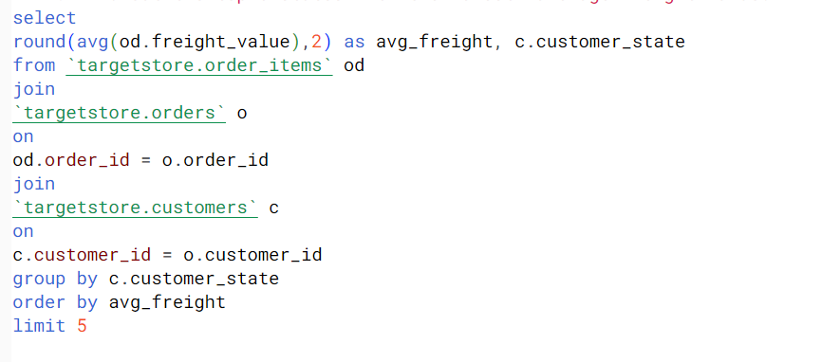

OUTPUT

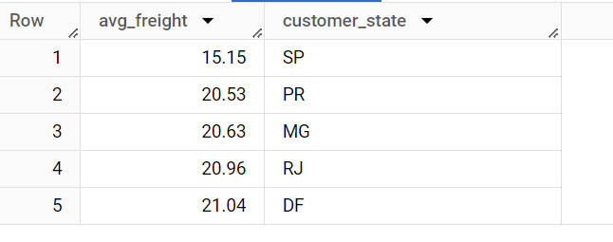

Find out the top 5 states where the order delivery is really fast as compared to the estimated date of delivery.

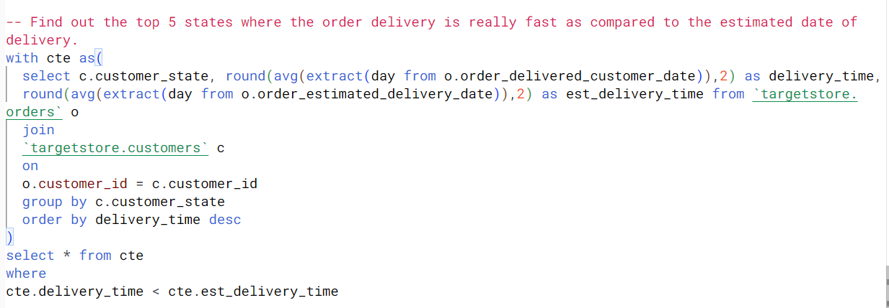

OUTPUT

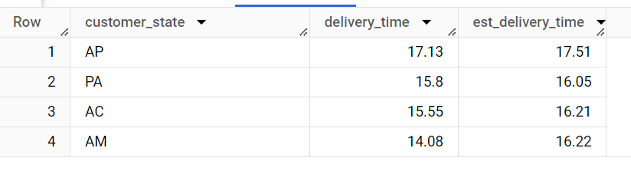

**Analysis based on the payments:**

1. Find the month on month no. of orders placed using different payment types.

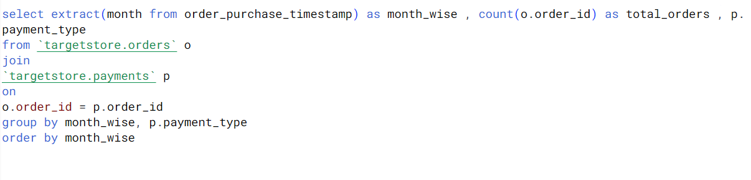

OUTPUT

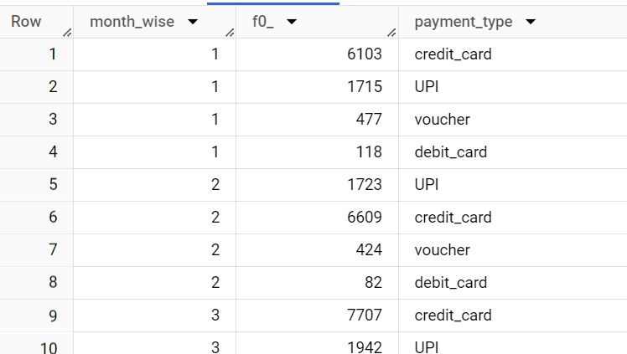

1. Find the no. of orders placed on the basis of the payment instalments that have been paid.

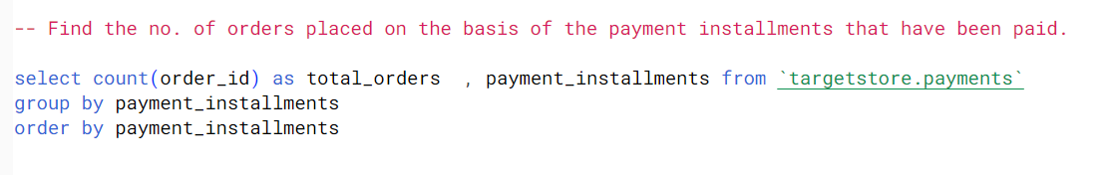

OUTPUT

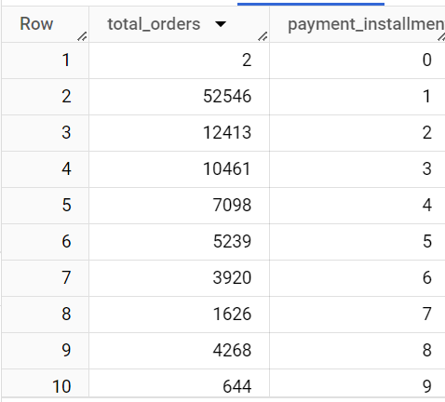

TABLEAU DASHBOARD

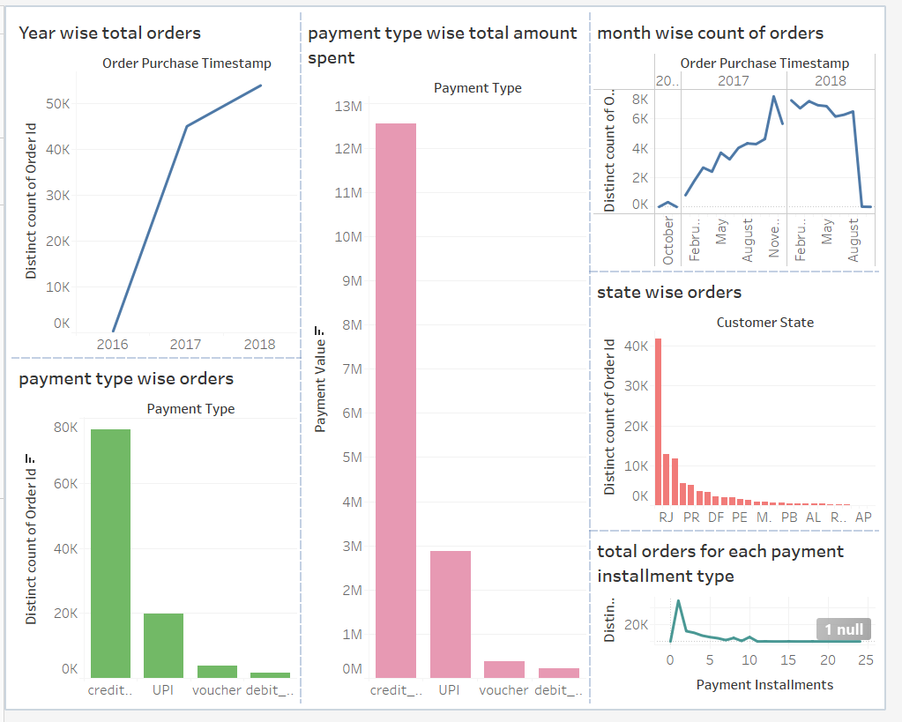

**BUSINEES INSIGHTS:**

* Business insights obtained are as follows:
* Year 2018 observed the highest purchase of orders.
* There was a significant drop in number of orders from august in the year 2018.
* State RJ has the most orders, whereas AP has least.
* The payment mode was credit card for most of the customers.
* Most customers opted for entire payment in one instalment.
* For the year 2017 the orders made were highest in October. However, for the year 2018 there was drop in orders from August. Hence, Target can focus on seasonal promotions, year-end sales , festive offers to attract more customers.
* Also, AP state has least orders. So, based on the state culture few promotions can be introduced. Also, home delivery feature can be added.
* More vouchers can be added to corporate firms as orders made by vouchers are less.